Project Planning Phase

Project Planning Template (Product Backlog, Sprint Planning, Stories, Storypoints)

Date | 22 October 2022
Team ID | PNT2022TMID13098
Project Name | Car Resale Value Prediction
Maximum Marks | 8 Marks

Product Backlog, Sprint Schedule, and Estimation (4 Marks)

Use the below template to create product backlog and sprint schedule

Sprint | Functional | User Story | User Story / Task | Story Points | Priority | Team
 | Requirement (Epic) | Number |  |  |  | Members
Sprint-1 | Pre-process data | USN-1 | Collect Dataset | 1 | Low | Karthica
Sprint-1 |  | USN-2 | Import required libraries | 1 | Low | Rajaparavathi
Sprint-1 |  | USN-3 | Read and clean data sets | 2 | Low | Rajaparavathi
Sprint-2 | Model building | USN-1 | Split data into independent and dependent | 3 | Medium | Deepashree
 |  |  | variables
Sprint-2 |  | USN-2 | Apply using regression model | 3 | Medium | Karthica
Sprint-3 | Application building | USN-1 | Build python flask application and HTML page | 5 | High | Balavarshini
 |  |  |  |  |  | &
 |  |  |  |  |  | Deepashree
Sprint-3 |  | USN-2 | Execute and test | 5 | High | Balavarshini
Sprint-4 | Training the model | USN-1 | Train machine learning model | 5 | High | Karthica &
 |  |  |  |  |  | Deepashree
Sprint-4 |  | USN-2 | Integrate flask | 5 | High | Karthica

Project Tracker, Velocity & Burndown Chart: (4 Marks)

Sprint | Total Story | Duration | Sprint Start Date |  | Sprint End Date |  | Story Points | Sprint Release Date
 | Points |  |  |  | (Planned) |  | Completed (as on | (Actual)
 |  |  |  |  |  |  | Planned End Date)
Sprint-1 | 20 | 6 Days | 24 | Oct 2022 | 29 | Oct 2022 | 20 | 29 | Oct 2022
Sprint-2 | 20 | 6 Days | 31 | Oct 2022 | 05 | Nov 2022 | 20 | 05 | Nov 2022
Sprint-3 | 20 | 6 Days | 07 | Nov 2022 | 12 | Nov 2022 | 20 | 12 | Nov 2022
Sprint-4 | 20 | 6 Days | 14 | Nov 2022 | 19 | Nov 2022 | 20 | 19 | Nov 2022

Velocity:

Imagine we have a 10-day sprint duration, and the velocity of the team is 20 (points per sprint). Let’s calculate the team’s average velocity (AV) per iteration unit (story points per day)
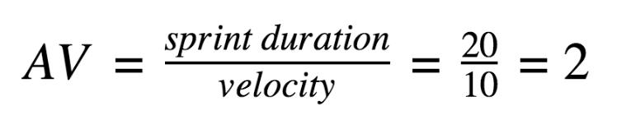

Burndown Chart:

A burn down chart is a graphical representation of work left to do versus time. It is often used in agile software development methodologies such as Scrum. However, burn down charts can be applied to any project containing measurable progress over time.
